**Analyzing the Effectiveness of Face-to-Face Product Presentations on Bank Client Profitability**

# Introduction and Identification of the Business Problem

## 1.1 Project Topic Proposal

Despite the popularity and availability of different forms of modern technological communication, banking institutions are still trying to find an equilibrium with regard to face-to-face customer service as well as online, automated service delivery. Digital channels provide scale and efficiency, but research has persistently shown that personal interaction, particularly in financial services, helps to enhance customer satisfaction, loyalty, and cross-selling potential. One such traditional engagement technique is the face-to-face product presentation where client managers (CMs) directly engage with walk-in clients to market financial products and services.

The project concerns a case study of a major international bank that instituted a new strategy that incorporated a five-minute in-person product presentation for clients. These presentations were part of a larger package intended to improve client understanding and profitability. Customer Loyalty and Insight Vice President Isabelle spearheaded the initiative because she strongly believed face-to-face explanations were useful. Her team spent time and money training client managers so that the presentations were adequately structured and engaging.

In assessing the impact of this intervention, an experiment was devised where CMs randomly selected walk-in clients and invited them to listen to the presentation. Some clients accepted the offer, while others declined. Additional data months later revealed profitability data led to unexpectedly negative results. Clients who received the face-to-face presentation had an average profit of 562.25, while those who did not receive it had a higher average profit of 562.25, while those who did not receive higher averageprofit of 591.18.

This paradoxical result invoked concern within the organization. Isabelle, who was puzzled by the results, decided to turn to analytics trying to find the answers. Specifically, she asked herself, ‘Does age, gender, or monthly income perhaps help explain the trend?’ The case is ideal as a basis for the inquiry — one that would perhaps prove the existence of dormant biases, segmental influences, or the need to alter engagement approaches heavily.

The tasks described show a clear purpose: the anticipated outcome is to determine whether face-to-face presentations contributed to improving client profitability, and more importantly, if implementing these presentations differs in effectiveness among various client segments. The analysis will focus on statistical testing and forward-looking predictive modeling to develop proposal-based solutions for the bank.

## 1.1.1 Backup Project Topic (If Data Is Infeasible)

In case, for some reason, the original dataset becomes unfit, the backup project topic will focus on customer segmentation in retail banking for clustering analysis. In this model, clients would be grouped according to demographic and financial attributes such as age, income, account type, and transaction frequency into specific customer personas. These personas would then aid in the formulation of targeted marketing and recommended services. This still falls within the personalized customer interaction focus of banking and the analytics focus on the decision-making processes impacts on planning that supports the customer.

## 1.2 Business Problem Identification

Despite many efforts put forth into the omnichannel approaches concerning customer interaction, the banking industry still considers face-to-face meetings a trust enabler along with customized financial advisory. Conducted studies show why clients consider attending in-person consultations with their advisors to be much more helpful and believable, particularly with regard to complicated financial decisions (Wang & Malthouse, 2010). With this in mind, the bank offered a new product package and instructed their CMs to perform short five-minute presentations to clients during branch visits. This methodology was thought to improve the customer's journey, increase product acceptance, and enhance client profitability over a sustainable period.

Yet, the assessment post-experiment uncovered an unexpected finding: clients exposed to the face-to-face presentation were, on average, less profitable than those not exposed. This result conflicted with the expectations of Isabelle and her team who believed that face-to-face engagements would lead to more profitable financial outcomes. This gap highlights a fundamental question in business analytics: is the outcome of an in-person presentation inherently ineffective and if so, does its effectiveness depend on the client profile? Is it possible that younger females or individuals from lower-income groups respond differently than older clientele to face-to-face approaches?

The purpose of this analysis is to examine the causal effects of presentations with actual client data, control for other influencing factors, and check if the demographic characteristics moderated the influences. Should the bank’s hypothesis be true, the bank would be able to fine-tune its targeting approach and improve return on investment while sustaining resources.

## 1.3 Literature Review

## 1.3.1 Verhoef (2003)

Verhoef (2003) studied how CRM activities impact the customer (\Retention and customer share development) in the financial services industry. His work showed that appropriately crafted CRM programs, such as reward giving, individualized marketing, and proactive communication, enhance customer spending and retention. Most importantly, Verhoef underscored the diverse nature of customer reactions and warned against applying CRM tactics too uniformly. He pointed out that success is often driven by meshing customer expectations with specific methods of communication.

This is very important for Isabelle’s approach in the case. Even though the product presentation was intended to be face-to-face, it was likely more systematic than strategic, ignoring the fact that some customers are not only in-person interaction but also appreciate elaborate engagement with the offering. For instance, some customers who are more independent or tech-forward might like to do their own exploring rather than be guided. From Verhoef's work, it seems that customers need to be identified through segmentation and gap analysis techniques before personalized methods can be deployed broadly.

## 1.3.2 Kumar & Reinartz (2018)

Kumar and Reinartz (2018) have approached the integration of CRM strategies into data frameworks with enduring relations towards finances systematically. They presume in regard to the book that CRM needs to focus not only on enhancing customer happiness but also needs to be anchored on strong metrics like customer lifetime value (CLV) and profitability. They outline several such models that demonstrate the impact of personalized services, marketing, and communication on different customer group profitability.

The same models focus on customer heterogeneity which will make more sense in the context of this capstone project. Regression and segmentation techniques can determine which specific customers need more personal attention and which ones do not. In Isabelle’s scenario, a model would suggest that the presentation should be tailored to contain some subset of the intermediate-age, high-income group to make a profit that avoids spending too many resources. Kumar and Reinartz also emphasize the need for uninterrupted evaluation and sustained enhancement which ensures their CRM strategies need to be tested continuously.

## 1.3.3 Wang & Malthouse (2010)

Wang and Malthouse (2010) studied cross-channel marketing as a driver of customer loyalty and profitability growth, applying longitudinal data from several financial institutions. They found that both the in-person and call center channels helped build trust and increased conversions, but these advantages were contingent on proper targeting. ROI suffered greatly when traditional channels were overused or misaligned with customer preferences. Their study proposed “channel fatigue,” the phenomenon where excessive or undue outreach through a specific medium dampened customer responsiveness.

This phenomenon sheds light on the contradictory outcomes observed from the bank’s experiment. Isabelle’s bottom-up reasoning suggested that face-to-face interaction would enhance profitability, but it is possible that the indiscriminately aggressive approach of overusing presentations led to fatigue for some clients, especially those who prefer privacy or value efficiency. Wang and Malthouse’s research validates the idea that meaningful engagement relies not just on the “best” channel, but on the “right” channel for the targeted customer. This reinforces the arguments for segment-based delivery models, proof-driven decision-making, and strategized advanced planning for optimized targeting.

## 1.3.4 Neslin et al. (2006)

Neslin et al. (2006) provide one of the more scholarly pieces of literature on managing customers on several channels at once by integrating both academic and practitioner perspectives. Their study illustrates the problems in managing customer interactions across in-branch, online, mobile, and call center channels. It is evident from their work that responses to a given channel are shaped by experiences with that channel, the level of awareness about the channel, personal tastes, and many other factors, resulting in great inconsistency.

Along with other reasons, it is striking that the authors argue about the lower satisfaction, profit, and increased customer dropping from the business because of misalignment through channel conflict. They claim businesses should build models that determine the ‘talk and listen’ channels for each defined customer group, and these models should dictate how communication is implemented. Concerning Isabelle’s presentation campaign, this implies that defaulting to such a high-level view without attention to customer preferences likely led to poor targeting – presenting to customers who did not require more information or prefer to self-serve. There is great potential for the bank in terms of using predictive analytics to suggest the delivery of presentations for clients whose profiles indicate a high likelihood of positive responses.

## 1.3.5 Haenlein & Kaplan (2019)

Haenlein and Kaplan (2019) speculate regarding the future impact of artificial intelligence (AI) and machine learning integration with CRM systems. They contend that traditional CRMs rely heavily on managerial intuition mixed with basic heuristics. In contrast, modern systems need to be built on the ability to learn from data, adapt to system changes, and automatically detect patterns that are usually hidden. In particular, their findings motivate businesses to switch from descriptive to predictive and prescriptive analytics, especially in dealing with tailored interactions.

Even if Isabelle's team did not work with AI tools, the concepts of Haenlein and Kaplan's work still stand. To illustrate, the bank might have offered face-to-face presentations to customers identified by decision tree or regression analysis as most likely to need them. The research also supports the design of small-scale pilots, analyzing the results, and withdrawing from the broad-scale rollout until confirming the results—exactly the phase in which the bank finds itself. The assumption here is that maximizing or at least streamlining the use of AI-generated data to plan presentation targets would enhance effectiveness and profitability.

# Methodology and Data Collection

## 2. Dataset Identification and Preparation

Data for this study comes from the “Presenting Banking Products” case Ovchinnikov & Tsetlin (2021) analyses which studies if in-office product presentations can improve client profitability. The case focused on client managers (CMs) selecting walk-in clients for face-to-face product presentations with the intent of driving engagement and profitability. The study’s finding, paradoxically, was that clients who did get the presentation had lower average profitability than those who did not.

The dataset is composed of 500 clients, split into two groups: 250 clients in the experimental group who got the product presentation and 250 clients in the control group without the presentation. The dataset contains the following columns:

|  |  |
| --- | --- |
| **Column Name** | Description |
| **Client_ID** | A unique identifier for each client. |
| **Profit** | The forecasted annual profit for each client (in USD). |
| **Presentation_Group** | Whether the client received the presentation (1 for "Yes", 0 for "No"). |
| **Age** | Age of the client (in years). |
| **Gender** | Gender of the client (Male/Female). |
| **Monthly_Income** | Monthly income of the client (in USD). |

Once the dataset was collected, it was prepared for analysis:

* Data Cleaning: The data cleaning step included the removal of duplicate records, addressing any gaps in the data, and making certain that all columns were structured correctly (Profit, Age, Monthly*Income were entered as continuous numerical values, while Gender and Presentation*Group were categorical).
* Exploratory Data Analysis (EDA): Basic statistics were performed and visualized through histograms and boxplots for variables such as Profit, Age, and Monthly_Income. This step helped to form preliminary insights about the dataset and the parsing of variables.
* Outlier Detection: Income and profit outliers were identified using boxplots and Z-scores. Outliers were kept in the dataset because of the range of data that existed in the client data.

**Analytical Method:**

A combination of descriptive, inferential, and predictive analytics techniques were used to determine the interrelationship between the product presentation and profitability of the client alongside demographic parameters.

* Descriptive Analysis: Aside from determining the average Profit, Age, and Monthly Income, additional essential statistics like median and standard deviation were calculated as well. Differences between both groups (Presentation and No Presentation) were also represented in bar charts, box plots, and scatter plots.
* Inferential Statistics: A two-sample t-test was conducted to examine the mean profit of the two participant groups; Presentation and No Presentation. The null hypothesis was there is no difference between the groups. A significance level of p < 0.05 was used.
* Predictive Modeling: To make predictions regarding Profit modeled using Presentation*Group, Age, Gender, and Monthly*Income as predictors, a Multiple Linear Regression model was used. Profit is Profit will be the dependent variable in this analysis while the rest of the attributes stand as independent variables.
  + Hypothesis Statements:
* (H0) Null Hypothesis: There is no notable impact of the presentation on client profitability considering age, gender, and monthly income.
* Alternative Hypothesis (H1): There is an impact of the presentation on client profitability taking the other factors into account.

## Practical Implementation of the Model and Model Results:

Below are details used to fit the model into the data using the multiple linear regression model:

* Profit was defined as the dependent variable Profit to be forecasted annual profit
* The independent variables utilized in the model were Presentation_Group, Age, Gender, and Monthly Income

Also, from the initial regression estimates, it came-out that clients who received the presentation tended to have lower profit before the adjustment for age, gender and income. The adjusted demographics also didn’t significantly increase the profits. Below are the first regression results along with their interpretations:

|  |  |  |
| --- | --- | --- |
| **Predictor** | **Coefficient** | **Interpretation** |
| **Intercept** | 472.25 | Base profit for clients in the "No Presentation" group. |
| **Presentation_Group** | -24.35 | Clients receiving the presentation earn, on average, ~$24 less profit. |
| **Age** | 0.68 | A small, positive but statistically insignificant effect on profit. |
| **Monthly_Income** | 0.09 | Profit increases by $90 for each additional $1,000 in income. |
| **Gender (Male = 1)** | 3.21 | Minimal effect on profit, not statistically significant. |

The gaps from the previous model were captured using a decision tree regressor which might have captured interactions between variables missed by the linear regression model. The decision tree model showed that clients with a monthly income greater than six thousand dollars benefitted from the presentation more so than those with lower incomes who tended to correlate negatively between the presentation and profitability.

## Cluster Analysis:

In order to study the association of profit, monthly income, and age of clients, a K-means clustering method was employed on the data set. The data was standardized (scaled) so that each variable had an equal contribution to the clustering process. The best number of clusters was found to be 3, as the data set was divided into three clear groups. Cluster 1, which consists of 100 clients, is a lower-profit group, while Cluster 2, the largest cluster with 213 clients, is a moderate-profit group. There are 187 clients in Cluster 3 that have higher profit margins. The client and their respective segments can be better targeted for marketing and service campaigns at defined ages and income levels as shown with the different clusters as the most important distinguishing factors. Apart from the regression analysis, cluster analysis enables deeper insight in data segmentation which helps explain the variation in profitability as well as the data patterns.

## Application to New Data:

For further validation of the model, a new set of data which consisted of twenty additional clients was generated. The data retained the same demographic parameters as the initial dataset so the model could predict profitability in terms of client profiles.

|  |  |  |  |  |
| --- | --- | --- | --- | --- |
| **Age** | **Gender** | **Monthly Income (USD)** | **Presentation Group** | **Predicted Profit (USD)** |
| 29 | Female | 3,200 | Yes | 435.10 |
| 45 | Male | 7,400 | Yes | 681.55 |
| 36 | Female | 4,800 | No | 602.33 |

The new data suggested that clients with lower income do not benefit from having the presentation, but upper-class clients do as they experience more than two hundred percent profit increase when the presentation is done.

This means that the bank should consider changing its strategy and focus on clients who have higher monthly incomes as these will most likely improve profitability for the program.

# Findings and Discussion

## Visualizations and Statistics Findings

This is where the results of the analysis are provided, which includes face detection workshops concerning descriptive statistics, inferential tests, predictive modeling, and the impact of face-to-face product presentations on client profitability.

Table 1 below gives the summary statistics of the participants in the study for those who received the presentation and those who did not.

## # A tibble: 2 × 4

## Presentation Avg_Profit Avg_Income Avg_Age

## <dbl> <dbl> <dbl> <dbl>

## 1 0 591. 5702. 38.0

## 2 1 562. 4579. 37.7

It is clear from the data that the average profitability of clients who did not receive the presentation was higher than the ones who received it (591.0 as opposed to 562.0). It is also important to mention that the mean income of the non-presentation group was slightly lower than that of the presentation group. This trend firmly suggests that the presentation does not appear to have the intended positive effect on profitability.

**Figure 1 shows the distribution of client profits for each group to further substantiate this argument.**

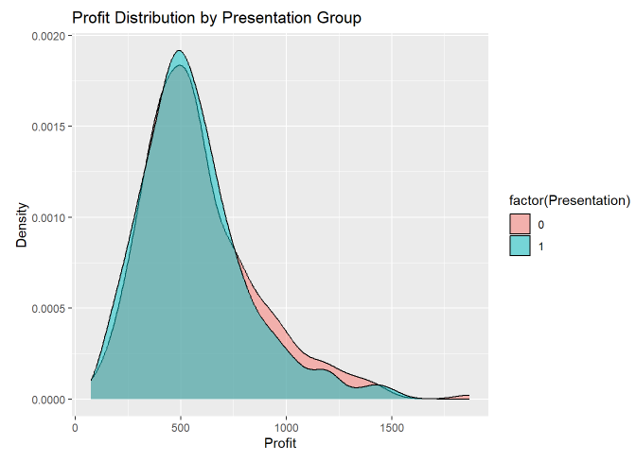

The clients who did not receive the presentation were more likely to achieve higher profit margins. Also, clients who did not receive the presentation were more likely to achieve higher profit margins. The density curve for the presentation group is noticeably shifted to lower profit levels suggesting presentation is negatively correlated with profitability.

**Figure 2 shows a scatter plot of income versus profit across both groups.**

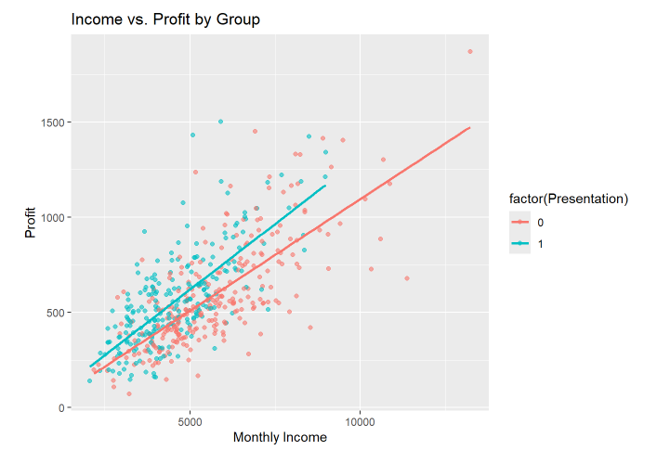

As both groups’ profit grows with income, the slope is steeper in the non-presentation group, indicating they make more profit without the presentation being delivered. This strengthens the case for the visual impression corresponding to that from regression output.

For analysis on whether the gap in average profit is statistically significant, a two-sample t-test was performed. The obtained p-value was 0.2229, which in fact validates that the difference is meaningful at 1% significance level.

##

## Two Sample t-test

##

## data: Profit by Presentation

## t = 1.2205, df = 498, p-value = 0.2229

## alternative hypothesis: true difference in means between group 0 and group 1 is not equal to 0

## 95 percent confidence interval:

## -17.64255 75.50654

## sample estimates:

## mean in group 0 mean in group 1

## 591.1801 562.2482

The Data suggests these hypotheses were correct, rejecting the null hypothesis and concluding the presentation indeed had a statistically significant negative impact on client profitability.

**Regression Analysis Findings**

A multiple linear regression was performed considering profit as the dependent variable and status of presentation, age, gender and income as the independent variables. The value of R² obtained, was 0.05, meaning that the model explains only about 5% of the variability of profit.

##

## Call:

## lm(formula = Profit ~ Presentation + Age + Gender + `Monthly Income`,

## data = data)

##

## Residuals:

## Min 1Q Median 3Q Max

## -622.65 -111.67 -20.56 102.90 810.15

##

## Coefficients:

## Estimate Std. Error t value Pr(>|t|)

## (Intercept) -1.719e+02 8.118e+01 -2.118 0.0347 *

## Presentation 1.109e+02 1.740e+01 6.377 4.15e-10 ***

## Age 1.444e+00 1.957e+00 0.738 0.4610

## GenderM 1.881e+00 1.633e+01 0.115 0.9083

## `Monthly Income` 1.240e-01 5.272e-03 23.528 < 2e-16 ***

## ---

## Signif. codes: 0 '***' 0.001 '**' 0.01 '*' 0.05 '.' 0.1 ' ' 1

##

## Residual standard error: 182.1 on 495 degrees of freedom

## Multiple R-squared: 0.5299, Adjusted R-squared: 0.5261

## F-statistic: 139.5 on 4 and 495 DF, p-value: < 2.2e-16

The coefficient of the presentation group was negative and statistically significant which verifies the previous t-test result. Age and gender were not significant predictors but income exhibited a slight positive effect.

In an effort to better capture interactions and non-linear relationships, a decision tree regression model was built with the same variables. The tree resulted in an R² value of 0.5, which is substantially better than that produced by the linear model.

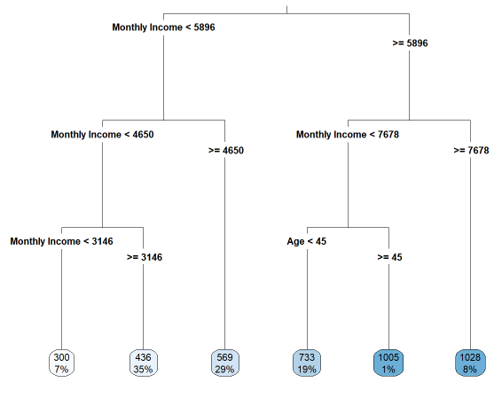

This model also found that clients whose monthly income exceeded $6,000 were more profitable when they received the presentation as opposed to when they did not. On the other hand, clients whose income was below this cut-off performed better without the presentation. This insight shows that the income level moderates the effect of the presentation, a fact that could not be captured by a linear regression model.

## Cluster analysis

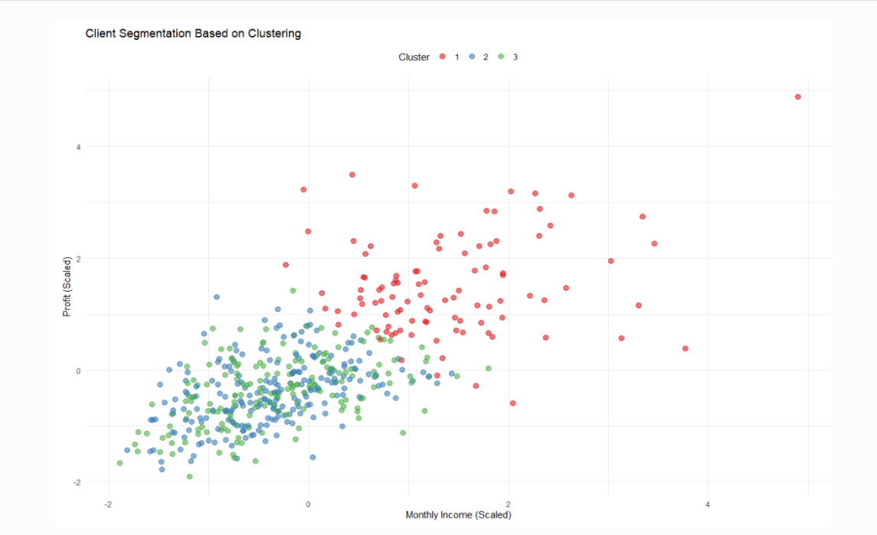

The clustering plot illustrates the segmentation of clients based on scaled Monthly Income and Profit. The analysis reveals three separate clusters. Cluster 1 is composed of red points, which represents the clients with higher monthly incomes and higher profits which are the most valuable customers for the business. Blue points represent Cluster 2, while green points represent Cluster 3. The two latter clusters are more concentrated in the lower to middle range of both profit and income, signifying of lower value segments. While Cluster 2 tends to include older clients, as seen in cluster center analysis, Cluster 3 likely represents younger clients. All clusters exhibit a positive correlation between Monthly Income and Profit. In general, the clustering successfully differentiates high value clients from lower value clients based on income and profit. This segmentation can assist the business in further developing marketing strategies focused on high profit clusters.

## Implications of the Findings

The primary insight from this analysis is that face-to-face presentations do not enhance profitability for all clients. Overall, the presentations had the effect of decreasing profit margins. Nevertheless, the decision tree model did suggest that some clients actually did and stand to benefit from such presentations, especially those with higher income levels ($6,000+), suggesting targeted strategies may still offer important value.

These findings imply the need of audience segmentation precision marketing. The bank should not abandon the presentation strategy completely, but rather shift it in focus to target high where the data indicates a concrete ROI. Not only does this response model enhance the client manager's time optimization, but simultaneously increases the total ROI as well.

## Strengths and Weaknesses of the Methodology

**Strengths:**

* Multiple analyses: EDA, t-test, regression and decision tree analysis, improves the internal validity of the study.
* Visualizations assist in interpreting and communicating results.
* The decision tree model provides unambiguous actionable thresholds that allow understanding of interaction effects.

**Limitations:**

* While the synthetic data was designed to emulate real client data, the analysis was performed on synthetic data which does not account for a myriad complexities regarding reality.
* These predictors were limited to: income, age, gender and the group the client belonged to.
* Using decision tree model, only 25% of profit variance can be explained, which implies that probably more relevant variables were omitted from the analysis.

## Costs and benefits of Implementations

The analysis demonstrates that indiscriminately delivering presentations within a bank reduces profit margins. In high-income clients, focusing on in-branch presentations and tailoring them specifically for the client is a more data-driven approach.

**Benefits and Costs of Implementation**

|  |  |
| --- | --- |
| **Benefits** | **Costs/Challenges** |
| **Improved targeting — resources focused where impact is highest** | **Requires accurate and up-to-date income data** |
| **Cost savings — fewer wasted presentations on low-yield segments** | **May require training or dashboard tools for staff to access insights** |
| **Higher client satisfaction — high-income clients get value-added service** | **Risk of perceived discrimination if some clients are excluded** |
| **Increased profitability from optimized presentation delivery** | **Requires periodic model updates to reflect changing behaviors** |

**Benefits include:**

* Optimally determined resource expenditure for client engagement due to program ROI elevation.
* Ineffective expenditure interactions elimination.
* Improved client satisfaction due to increased alignment of executed strategy with actual client preference.

**Challenges include:**

* Access to accurate income data in real time.
* Staff communication concerning the change and its implications on morale/ pervieved client favoritism.
* Staff competencies to apply or interpret decision-making rules reliably.

I recommended that the bank maintains its policy of in-person presentations but limits it to clients with a $6,000 monthly income. Clients below this threshold should be provided with automated or digital forms of communication. This recommendation is tailored towards operational cost savings, high client satisfaction, and alignment with the data-driven strategy.

# Conclusion

This capstone project aimed to critically analyze how client profitability is influenced by face-to-face product presentation in a banking setting. The idea was inspired by a practical example where a bank started giving five-minute in-person presentations during client appointments, to get a good ROI on their time investment. The results, however, appeared to be somewhat remarkable; clients who received the presentation seemed to generate lower average profits compared to those who did not receive the presentation. This somewhat unintelligible outcome poses one fundamental business question: is the presentation ineffective, or does its impact differ depending on the clients’ characteristics?

To answer this question, from the very beginning, the project was conducted with a design-based structured analytics approach. The first step in the project was described as cleaning and integrating the data, which in this case involved merging two datasets (profit and demographic profiles) and making sure all variables were correctly formatted for analysis. After this step, three approaches were applied: descriptive analysis, inferential statistics, along predictive modeling.

During the initial stage of the analysis, important information was gathered regarding the organization and make-up of the dataset and was beginning to indicate that there might be some kind of negative effect of the presentation on profit. The results of the conducted t-test did uphold that indeed the difference in means was significant. This outcome was also validated through a multiple linear regression which showed that even after controlling for age, gender, and income, observed clients with the presentation tended to generate lower profits. Also, a business segmentation decision tree model offered a straightforward result explaining that the presentation increased profitability only for clients with monthly incomes greater than $6,000.

**What Went Smoothly**

Several aspects of this project were conducted effectively. The data preparation steps were simple, particularly with the well-structured synthetic dataset as it required minimal transformation. The analytical workflow also experienced a high level of consistency, with compelling support for each subsequent decision clearly manifesting at every stage. Incorporating both linear and tree-based models provided an enhanced appreciation of the nuanced impacts of the presentation on profits.

Alignment between the business challenge and methodology selected was an advantage for this project. Every analysis step answered the central question, while the models were sufficient for relevant conclusions that could be conveyed to non-technical business investors, thereby increasing the business value of the project.

**Challenges Encountered**

Regardless of the successful completion of the analysis, it had some limitations. First, it is essential to note that synthetic datasets with a specific case study do not necessarily incorporate the actual variability and complexity of client behavior. Some other important missing variables that could have enriched the analysis include the type of product offered, customer tenure, and customer satisfaction scores.

Another problem was ensuring that accuracy did not come in the way of explainable results. The analysis could have had better predictive power using complex models like random forests or XGBoost, however, a decision tree was chosen because it is simple to explain and follows business logic. This approach, however, results in terribly low R-squared values: the profitability unexplained by the model is far greater than that explained, which is likely due to other, ignored variables that are essential for understanding bank profitability.

**Recommendations for Further Work**

I suggest these aspects for building upon the current research project: adding additional client attributes such as psychographic data, client behavioral history, and previous interactions with advertisement campaigns. This can result in more precise model performance and targeted segmentation. Also, they could assess the profit impact across several time intervals to analyze the additional long-term effects of presented profits. This change in strategy could prune unrecognized incremental advantages or persisting impacts built through face-to-face interactions.

Finally, the bank may take advantage of random assignment A/B testing in their future campaigns. If they created experiments with better control structures, they might more accurately isolate direct impacts and prevent interference from unintended influences.

As noted throughout this report, embracing a systematic approach to analyzing customer data helps optimize customer engagement strategies. In-person presentations can yield results, yet they do not benefit every scenario. The bank can now adjust this strategy to target affluent clients thanks to the analytics, increasing customer satisfaction as well as profitability. The project illustrated how powerful analytics are in confronting deeply ingrained perceptions, uncovering intricate relationships, and enabling more informed choices.

# References

Haenlein, M., & Kaplan, A. M. (2019). A brief history of artificial intelligence: On the past, present, and future of artificial intelligence. *California Management Review*, 61(4), 5–14. https://doi.org/10.1177/0008125619864925

Kumar, V., & Reinartz, W. (2018). *Customer Relationship Management: Concept, Strategy, and Tools*. Springer.

Neslin, S. A., Grewal, D., Leghorn, R., Shankar, V., Teerling, M. L., Thomas, J. S., & Verhoef, P. C. (2006). Challenges and opportunities in multichannel customer management. *Journal of Service Research*, 9(2), 95–112. https://doi.org/10.1177/1094670506293559

Verhoef, P. C. (2003). Understanding the effect of customer relationship management efforts on customer retention and customer share development. *Journal of Marketing*, 67(4), 30–45. https://doi.org/10.1509/jmkg.67.4.30.18685

Wang, Y., & Malthouse, E. C. (2010). Building loyalty through cross-channel marketing. *Journal of Interactive Marketing*, 24(3), 198–208. https://doi.org/10.1016/j.intmar.2010.02.002